
Maize Analytics

In-Depth VIP Patients and Watchlist Users

Designate certain patients as VIPs to make it easier to monitor accesses to their records. VIPs are listed on the Dashboard, along with a direct link to the VIP settings page:
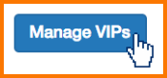
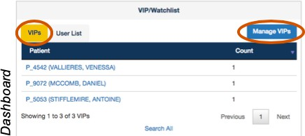

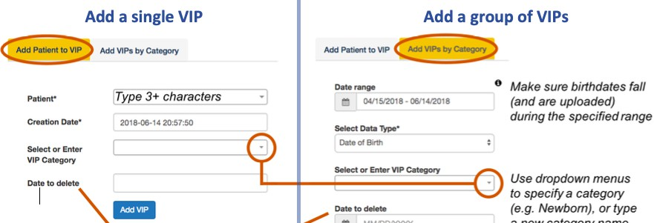

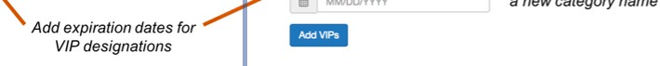
Add categories to help classify VIPs. When searching accesses, you can enter “VIP” or a category in the “General Search” box.
Current VIPs are listed at the bottom of the page. Navigate the list using clickable icons. Delete VIPs using the red buttons.

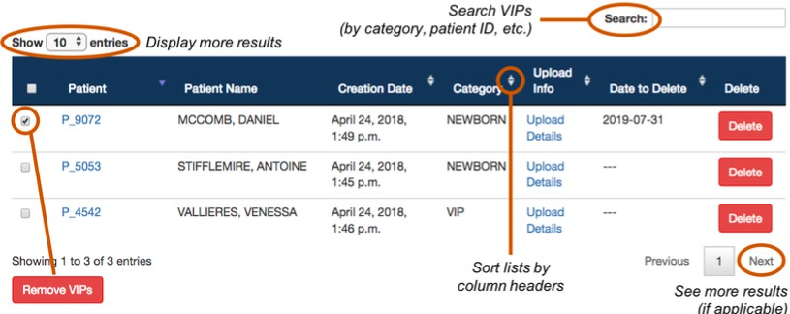

VIP Web Crawler - Automatically Monitor for Patients Appearing in Online News Articles
The VIP Web Crawler can be set to crawl any URL/website of interest, to look for patients that may have been treated at your organization. Your Maize support team will configure this for you.

How Does it Work?

Organizations generally pick 1-3 local news websites (e.g. newspaper, television, etc.) to crawl. The VIP Web Crawler looks at these sites and identifies full name matches of patients that appear in the Maize Explanation Based Auditing System (EBAS).

Matching Rules
The patient name must appear at least twice in the article, and in the actual sentence containing the patient’s name, there must be one of the following words:

abuse, accident, ambulance, assault, attack, celebrity, collision, cops, criminal, crisis, critical, death, died, drug, dui, emergency, fentanyl, fire, gang, guilty, gun, homicide, hospital, injur, knife, life, medic, murder, overdose, police, politic, precinct, prosecute, protest, rape, riot, shoot, shot, stroke, suicide, terror, trauma, victim, violence, wound

Note: Organizations can add more words to the above list. Also, they may request variations of the name of their Hospital as being a required element to be present in the article (e.g. John Smith is being treated at General Hospital due to a gunshot wound he received during an altercation on October 12th). Adding Hospital name(s), and variations of it, as a required element will minimize false p ositives from irrelevant sources.

Pending VIPs
The Pending VIP tab contains a table of all active patients (i.e. have accesses within the previous 7 days), whose full name (First and Last) have been found in a recent (7 day) web article and meets the criteria outlined above.
In the table, the Patient ID, Patient’s Full Name, Date of Last Access, Date of Article, and a snippet of the sentence containing the patient’s name (with a hyperlink to the full article) are displayed.

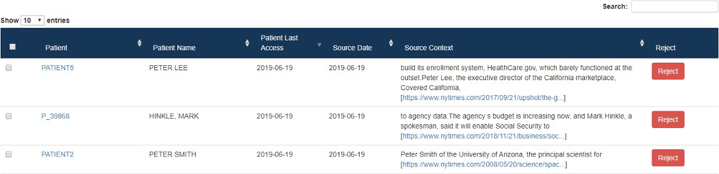

For patients that are not a match, and/or are not wanted to be added to the Patient VIP list, select the patients to be removed by clicking on the checkbox, then click the Reject button. This will remove the entry from the Pending VIP table

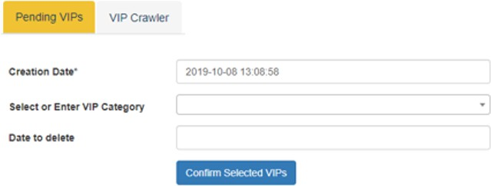

To confirm pending VIPs (add to the VIP Watchlist), select the desired patients from the table (click the check box to the left of patient name).
Use dropdown menu to specify a category or type a new VIP Category name
Click the Confirm Selected VIPS button. Confirmed patients will be removed from the Pending VIP list and added to the Add Patient to VIP tab.
VIP Category and Date to Delete can be left blank.

If these fields are not completed:

- VIP Category will be defaulted to the generic VIP designation.

- Patient will remain as a VIP indefinetly, unless you choose to remove them from the Add Patient to VIP tab.
Recommendation: The Pending VIP table should be checked frequently for matches and to clear unwanted results.

VIP Crawler
The VIP Crawler tab contains a historic record of all Pending VIPs, whether they were eventually confirmed, rejected or are still pending (even though they may no longer appear in the Pending VIPs table due to being older than 7 days).

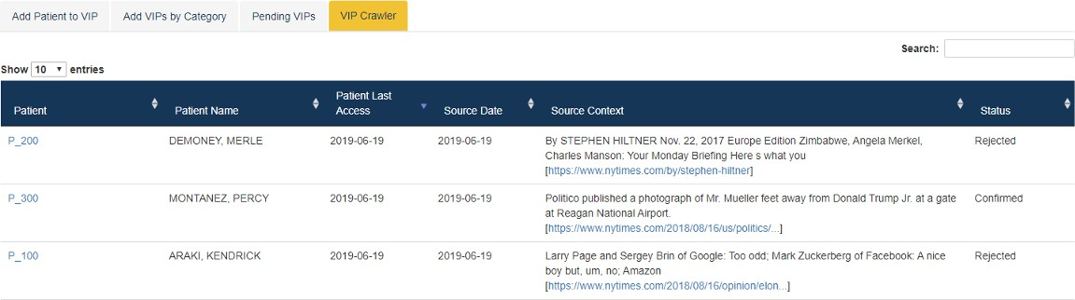

Place certain users on the Watchlist to make it easier to monitor their accesses. The Watchlist is displayed on the Dashboard, with a direct link to the Watchlist settings page:
